be-openapi-javasdk接入文档

# 概述

本文档主要针对java sdk接入的说明。

阅读对象：商户网站的java开发人员。

开发进度：目前网关及sdk高速开发中，文档将频繁变更，请使用方及时更新

# 前置条件

### Jdk

Jdk 8 以上

在命令行中执行校验命令java –version，返回以下类似

java version "1.8.0_191"

Java(TM) SE Runtime Environment (build 1.8.0_191-b12)

Java HotSpot(TM) 64-Bit Server VM (build 25.191-b12, mixed mode)

如果返回不正确，参考java官方安装文档

### Maven

Maven 3.0以上，在命令行中执行校验命令mvn –version，返回以下类似

Apache Maven 3.6.0 (97c98ec64a1fdfee7767ce5ffb20918da4f719f3; 2018-10-25T02:41:47+08:00)

Maven home: D:\apache-maven-3.6.0\bin\..

Java version: 1.8.0_191, vendor: Oracle Corporation, runtime: C:\Program Files\Java\jdk1.8.0_191\jre

Default locale: zh_CN, platform encoding: GBK

OS name: "windows 7", version: "6.1", arch: "amd64", family: "windows"

如果返回不正确，参考maven官方安装文档

### 导入maven库

导入本地库和远程库只要执行一个即可，根据使用方的研发环境决定。

#### 导入本地库

移动到‘执行库’子目录

mvn install:install-file -Dfile=sign-tool-0.2-SNAPSHOT.jar -DpomFile=sign-tool-0.2-SNAPSHOT.pom

mvn install:install-file -Dfile=be-openapi-0.3-SNAPSHOT.jar -DpomFile=be-openapi-0.3-SNAPSHOT.pom

mvn install:install-file -Dfile=be-openapi-sdk-0.6-SNAPSHOT.jar -DpomFile=be-openapi-sdk-0.6-SNAPSHOT.pom

mvn install:install-file -Dfile=cap-openapi-0.1.2-SNAPSHOT.jar -DpomFile=cap-openapi-0.1.2-SNAPSHOT.pom

#### 导入远程库()

移动到‘执行库’子目录

mvn deploy:deploy-file -Durl=公司maven库url路径 -DrepositoryId=库名 -Dfile= sign-tool-0.2-SNAPSHOT.jar -DpomFile= sign-tool-0.2-SNAPSHOT.pom

mvn deploy:deploy-file -Durl=公司maven库url路径 -DrepositoryId=库名 -Dfile= be-openapi-0.3-SNAPSHOT.jar -DpomFile= be-openapi-0.3-SNAPSHOT.pom

mvn deploy:deploy-file -Durl=公司maven库url路径 -DrepositoryId=库名 -Dfile= be-openapi-sdk-0.3-SNAPSHOT.jar -DpomFile=be-openapi-sdk-0.3-SNAPSHOT.pom

mvn deploy:deploy-file -Durl=公司maven库url路径 -DrepositoryId=库名 -Dfile= cap-openapi-0.0.3-SNAPSHOT.jar -DpomFile= cap-openapi-0.0.3-SNAPSHOT.pom

### 使用方项目导入maven依赖声明

<dependency>

<groupId>io.bitexpress.openapi</groupId>

<artifactId>be-openapi-sdk</artifactId>

<version>0.6-SNAPSHOT</version>

</dependency>

<dependency>

<groupId>io.bitexpress.openapi</groupId>

<artifactId>cap-openapi</artifactId>

<version>0.1.2-SNAPSHOT</version>

</dependency>

<!--http组件默认使用apache httpclient4,也可以切换成okhttp -->

<dependency>

<groupId>org.apache.httpcomponents</groupId>

<artifactId>httpclient</artifactId>

<version>4.5.6</version>

</dependency>

以上声明会将级联依赖一并导入

sdk级联依赖具体内容如下

io.bitexpress.openapi:be-openapi-sdk:jar:0.4-SNAPSHOT

+- io.bitexpress.openapi:be-openapi:jar:0.3-SNAPSHOT:compile

| +- javax.validation:validation-api:jar:2.0.1.Final:compile

| \- com.fasterxml.jackson.core:jackson-annotations:jar:2.9.0:compile

+- org.apache.commons:commons-lang3:jar:3.7:compile

+- com.fasterxml.jackson.core:jackson-databind:jar:2.9.8:compile

| \- com.fasterxml.jackson.core:jackson-core:jar:2.9.8:compile

+- org.springframework:spring-web:jar:5.1.6.RELEASE:compile

| +- org.springframework:spring-beans:jar:5.1.6.RELEASE:compile

| \- org.springframework:spring-core:jar:5.1.6.RELEASE:compile

| \- org.springframework:spring-jcl:jar:5.1.6.RELEASE:compile

+- io.bitexpress.utility:sign-tool:jar:0.2-SNAPSHOT:compile

| +- org.bouncycastle:bcprov-jdk15on:jar:1.60:runtime

| +- org.bouncycastle:bcpkix-jdk15on:jar:1.60:runtime

| +- commons-codec:commons-codec:jar:1.11:compile

| +- commons-io:commons-io:jar:2.6:compile

| \- org.slf4j:slf4j-api:jar:1.7.25:compile

+- org.apache.httpcomponents:httpclient:jar:4.5.6:compile

| \- org.apache.httpcomponents:httpcore:jar:4.4.10:compile

+- org.testng:testng:jar:6.14.3:test

| +- com.beust:jcommander:jar:1.72:test

| \- org.apache-extras.beanshell:bsh:jar:2.0b6:test

+- ch.qos.logback:logback-classic:jar:1.2.3:test

+- ch.qos.logback:logback-core:jar:1.2.3:test

\- org.slf4j:jcl-over-slf4j:jar:1.7.25:test

# 公密钥准备

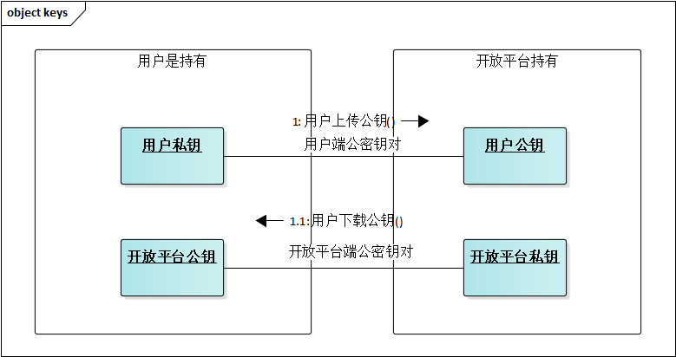

公密钥对格式都是pem格式，使用app生成用户私钥，并使用app将公钥部分上传到开放平台，并使用从商户控台下载开放平台公钥。

# 接口说明

## 概览图

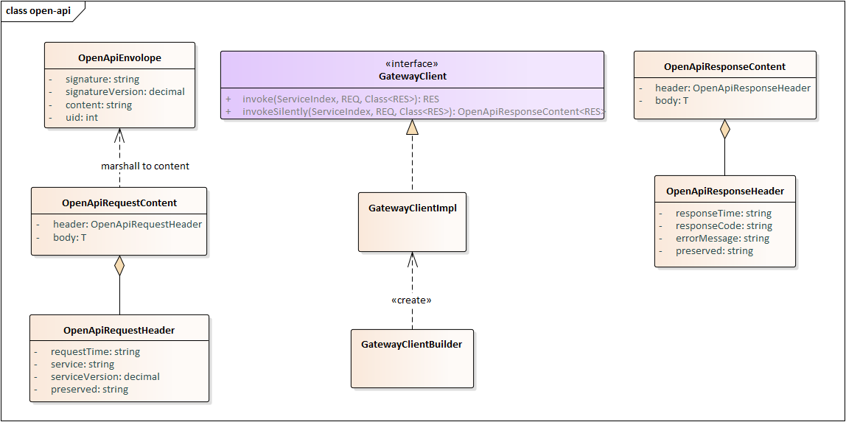

## 功能说明

### GatewayClient及GatewayClientImpl

#### 初始化

GatewayClientBuilder builder = **new** GatewayClientBuilder();

// 设置用户uid

builder.setUid(***123L***);

// 设置服务地址

builder.setUrl("http://localhost:8080/gateway.do");

// 设置客户端私钥

builder.setClientPrivateKeyFilePath("src/test/resources/user_key_pair/private_key.pem");

gatewayClient = builder.build();

### 创建及时到账交易

CashierAcquireRequest cashierAcquireRequest = new CashierAcquireRequest();  
cashierAcquireRequest.setAmount(new BigDecimal(1.001));  
cashierAcquireRequest.setName("test");  
cashierAcquireRequest.setNotifyUrl("http://localhost:8081/crypto-asset-payment/services/restful/ping");  
cashierAcquireRequest.setAssetCode("ETH");  
cashierAcquireRequest.setOutTradeNo("20190424141559");  
ServiceIndex serviceIndex = new ServiceIndex("createInstantTrade", GatewayClientImpl.DEFAULT_SIGNATURE_VERSION);  
CashierAcquireResponse response = gatewayClient.invoke(serviceIndex, cashierAcquireRequest, CashierAcquireResponse.class);  
String url = response.getUrl();

### 创建法币收单交易

String outTradeNo = "1557825182529";

FiatAcquireRequest legalCurrencyCashierAcquireRequest = new FiatAcquireRequest();

legalCurrencyCashierAcquireRequest.setOutTradeNo(outTradeNo);

legalCurrencyCashierAcquireRequest.setCurrency(Currency.CNY);

legalCurrencyCashierAcquireRequest.setEmail("abc123@163.com");

legalCurrencyCashierAcquireRequest.setLanguage("zh");

legalCurrencyCashierAcquireRequest.setName("legalPayment");

legalCurrencyCashierAcquireRequest.setNotifyUrl(NOTIFY_URL);

legalCurrencyCashierAcquireRequest.setAssetCode("USDT_ERC20");

legalCurrencyCashierAcquireRequest.setFiatAmount(new BigDecimal("20"));

ServiceIndex serviceIndex = new ServiceIndex("createFiatAcquireOrder", GatewayClientImpl.DEFAULT_SIGNATURE_VERSION);

CashierAcquireResponse response = gatewayClient.invoke(serviceIndex, legalCurrencyCashierAcquireRequest, CashierAcquireResponse.class);

System.out.println(response);

String url = response.getUrl();

### 查询及时到账交易

String outTradeNo= "20190424181332";  
CashierAcquireQueryRequest cashierAcquireQueryRequest = new CashierAcquireQueryRequest();  
cashierAcquireQueryRequest.setOutTradeNo(outTradeNo);  
ServiceIndex serviceIndex = new ServiceIndex("queryInstantTrade", GatewayClientImpl.*DEFAULT_SIGNATURE_VERSION*);  
CashierAcquireOrder cashierAcquireOrder = gatewayClient.invoke(serviceIndex, cashierAcquireQueryRequest, CashierAcquireOrder.class);

### 付款到地址

WithdrawRequest withdrawRequest = new WithdrawRequest();  
withdrawRequest.setAmount(new BigDecimal(5.05));  
withdrawRequest.setNotifyUrl("http://localhost:8081/crypto-asset-payment/services/restful/ping");  
withdrawRequest.setPayerUid("459");  
withdrawRequest.setReceiveAddress("0xf8d6478ee5bbb23e5084fbec67f6c7ad6001d026");  
withdrawRequest.setAssetCode("ETH");  
withdrawRequest.setOutTradeNo("20190424141559");  
ServiceIndex serviceIndex = new ServiceIndex("payToAddress", GatewayClientImpl.*DEFAULT_SIGNATURE_VERSION*);  
WithdrawOrder withdrawOrder = gatewayClient.invoke(serviceIndex, withdrawRequest, WithdrawOrder.class);

### 查询付款到地址

String outTradeNo= "20190424141559";  
WithdrawQueryRequest withdrawQueryRequest = new WithdrawQueryRequest();  
withdrawQueryRequest.setOutTradeNo(outTradeNo);  
ServiceIndex serviceIndex = new ServiceIndex("queryPayToAddress", GatewayClientImpl.DEFAULT_SIGNATURE_VERSION);  
WithdrawOrder withdrawOrder = gatewayClient.invoke(serviceIndex, withdrawQueryRequest, WithdrawOrder.class);

### 付款到账户

TransferRequest transferRequest = new TransferRequest();  
transferRequest.setAmount(new BigDecimal(3.33));  
transferRequest.setNotifyUrl("http://localhost:8081/crypto-asset-payment/services/restful/ping");  
transferRequest.setPayerUid("459");  
transferRequest.setPayeeUid("31351221001");  
transferRequest.setAssetCode("ETH");  
transferRequest.setOutTradeNo("20190424151259");  
ServiceIndex serviceIndex = new ServiceIndex("payToAccount", GatewayClientImpl.*DEFAULT_SIGNATURE_VERSION*);  
TransferOrder transferOrder = gatewayClient.invoke(serviceIndex, transferRequest, TransferOrder.class);

### 查询付款到账户

String outTradeNo= "20190424151259";  
TransferQueryRequest transferQueryRequest = new TransferQueryRequest();  
transferQueryRequest.setOutTradeNo(outTradeNo);  
ServiceIndex serviceIndex = new ServiceIndex("queryPayToAccount", GatewayClientImpl.*DEFAULT_SIGNATURE_VERSION*);  
TransferOrder transferOrder = gatewayClient.invoke(serviceIndex, transferQueryRequest, TransferOrder.class);

### 查询单一币种账号余额

QueryBalanceRequest queryBalanceRequest = new QueryBalanceRequest();

queryBalanceRequest.setAssetCode("ETH");

ServiceIndex serviceIndex = new ServiceIndex("queryBalance", GatewayClientImpl.DEFAULT_SIGNATURE_VERSION);

Balance balance = gatewayClient.invoke(serviceIndex, queryBalanceRequest, Balance.class);

System.out.println(balance);

### 创建为订单付款交易

String outTradeNo = formatter.format(LocalDateTime.now());

CreatePaymentForOrderRequest createPaymentForOrderRequest = new CreatePaymentForOrderRequest();

createPaymentForOrderRequest.setAmount(new BigDecimal("2.0012301"));

createPaymentForOrderRequest.setNotifyUrl(NOTIFY_URL);

createPaymentForOrderRequest.setPayeeUid("459");

createPaymentForOrderRequest.setTargetTradeId("20190524000044084");

createPaymentForOrderRequest.setAssetCode("ETH");

createPaymentForOrderRequest.setOutTradeNo(outTradeNo);

ServiceIndex serviceIndex = new ServiceIndex("createPaymentForOrder", GatewayClientImpl.DEFAULT_SIGNATURE_VERSION);

PaymentOrder paymentOrder = gatewayClient.invoke(serviceIndex, createPaymentForOrderRequest, PaymentOrder.class);

System.out.println(paymentOrder);

### 为订单付款的交易查询

String outTradeNo = "20190524135515";

QueryPaymentForOrderRequest queryPaymentForOrderRequest = new QueryPaymentForOrderRequest();

queryPaymentForOrderRequest.setOutTradeNo(outTradeNo);

ServiceIndex serviceIndex = new ServiceIndex("queryPaymentForOrder", GatewayClientImpl.DEFAULT_SIGNATURE_VERSION);

PaymentOrder paymentOrder = gatewayClient.invoke(serviceIndex, queryPaymentForOrderRequest, PaymentOrder.class);

System.out.println(paymentOrder);

### 为订单付款的交易分页查询

QueryPaymentForOrderPageRequest queryPaymentForOrderPageRequest = new QueryPaymentForOrderPageRequest();

Date now = new Date();

Date startTime = DateUtils.addMinutes(now, -10);

queryPaymentForOrderPageRequest.setStartTime(startTime);

queryPaymentForOrderPageRequest.setEndTime(now);

SortPageParam sortPageParam = new SortPageParam();

sortPageParam.setSize(5);

sortPageParam.setNumber(0);

queryPaymentForOrderPageRequest.setSortPageParam(sortPageParam);

ServiceIndex serviceIndex = new ServiceIndex("queryPaymentForOrderPage", GatewayClientImpl.DEFAULT_SIGNATURE_VERSION);

Pagination<PaymentOrder> paymentOrderPagination = gatewayClient.invoke(serviceIndex, queryPaymentForOrderPageRequest, Pagination.class);

System.out.println(paymentOrderPagination);

## 异步通知消息解析

异步通知消息解析仅处理数据解析及鉴权操作，消息报文本身需要研发自己获取

### 初始化

MapGatewayNotificationParserBuilder builder = new MapGatewayNotificationParserBuilder();

builder.setUid(UID);

builder.setServerSidePublicKeyFilePath("src/test/resources/user_key_pair/public_key.pem");

Map<ServiceIndex, Class> notificationClassMap = new HashMap<>();

notificationClassMap.put(new ServiceIndex("payToAccount", new BigDecimal("1.0")), TransferOrder.class);

notificationClassMap.put(new ServiceIndex("payToAddress", new BigDecimal("1.0")), WithdrawOrder.class);

notificationClassMap.put(new ServiceIndex("createAcquireOrder", new BigDecimal("1.0")),

CashierAcquireOrder.class);

notificationClassMap.put(new ServiceIndex("createFiatAcquireOrder", new BigDecimal("1.0")),

CashierAcquireOrder.class);

notificationClassMap.put(new ServiceIndex("createPaymentForOrder", new BigDecimal("1.0")), PaymentOrder.class);

builder.setNotificationClassMap(notificationClassMap);

GatewayNotificationParser parser = builder.build();

反序列化的映射关系是要自己维护，样例中的映射关系是目前用到，后续会随着功能增加同步更新配置代码

### 接收转账消息

String requestEnvelopeStr = FileUtils.readFileToString(new File("src/test/resources/notification.json"),

StandardCharsets.UTF_8);//数据来源根据实际情况获取

OpenApiRequestContent<PaymentOrder> parseNotification = parser.parseNotification(requestEnvelopeStr);